

**Senior Design Project**

**The Design of an Educational Virtual Reality Video Game for Electrical Engineers**

ENGE476 Senior Design Project I

Department of Engineering and Aviation Sciences

University of Maryland, Eastern Shore

Tyler Gantz

Project Advisor, Dr. Lei Zhang

Submitted

Mon. Day, Year

Special notice for formatting:

1. Don’t add any blank rows. Use spacing or page breaks.
2. Every figure or picture inserted in the text, must be accompanied with the caption and detailed description.
3. Keep the formatting consistent (learn and apply the MS ‘Styles’ in formatting).
4. The final report didn’t meet the basic formatting requirements won’t be accepted.

List of Contents

Special notice for formatting: 2

1. Don’t add any blank rows. Use spacing or page breaks. 2

2. Every figure or picture inserted in the text, must be accompanied with the caption and detailed description. 2

3. Keep the formatting consistent (learn and apply the MS ‘Styles’ in formatting). 2

4. The final report didn’t meet the basic formatting requirements won’t be accepted. 2

Table of Contents 3

Abstract 2

1. Introduction 3

1.1 Backgound/Motivation 3

1.2 Objective 3

1.3 Design Requirements 3

1.4 Design Constraints 3

1.5 Design Methods 3

2. Project Description 4

2.1 System Description 4

2.2 System Diagram 4

2.3 System Functions 4

3. Implementation Plan 6

3.1 Tasks 6

3.2 Team Organization 7

3.2.1 Responsibility of Team Member 1. 7

3.2.2 Responsibility of Team Member 2. 7

3.3 Timeline/Milestones/Delivery Plan 7

4. Implementation 8

4.1 Implementation of Task 1. 8

4.2 Implementation of Task 1. 8

5. Conclusion. 9

Acknowledgement 10

Appendix 11

A. Component Specs 11

1. Specs of Arduino Due 11

2. Specs of Raspberry Pi 11

B. Source Code. 11

1. Source Code of Graphic User Interface 11

2. Source Code of Robotic Arm 11

REFERENCES 12

List of Figures

Table 1. Project Timeline and Delivery Plan 9

List of Tables

Abstract

By the end of the project, summarize the project into short text and put here.

1. Introduction

## Backgound/Motivation

From the beginning of any engineering program, students are required to take difficult courses that involve new math and physics concepts. From experience, this can be overwhelming, as a lot of these concepts are foreign both mathematically and mentally. Visualizing topics such as circuit configurations or truss problems in statics are not always intuitive to new students.

As it stands, the standard curriculum for engineering students at UMES consists of just lectures with a handful of labs included in a four-year degree program. While this proves to be successful for most students, more learning tools are always welcome. Now, what if those learning tools broke away from the monotony of the typical lecture, where students sit quietly and takes notes, with the only interaction being asking questions to a professor. What if they provided an alternative to a lab, which typically only has students flipping a switch, measuring a value, then flip another switch, measure that value. In other words, what if there was a learning tool available to students that is both fun and interactive, but still educational.

This is where game-based learning comes in. Game-based learning, or GBL, uses competitive exercises, either pitting students against each other or getting them to challenge themselves in order to motivate them to learn better.Incorporating GBL into a curriculum has shown to motivate students to learn and, in turn, learn more effectively. Games provide an element of fantasy to the players, something that is not present in the typical lecture or lab. This element is what provides a fun and memorable experience for the students playing, which is what makes this approach to education so effective. [1]

Technology in gaming has come a long way since its beginning back in the 80’s. Visually, games evolved from the 8-bit, pixelated graphics to the stunning 4K graphics found in games today. The way the players control and play their games has also evolved from using simple game 8 button game pads to full motion controls. However, there is one innovation that stands out among the rest, and that’s virtual reality (VR). Especially in recent years, VR has become a prominent part of gaming with the release of popular hardware, like the HTC Vive and the Oculus Rift. Gaming platforms, such as Playstation, Steam, and various mobile applications all offer VR support with compatible hardware. Having this technology at our disposal is great, but is it really that vital to incorporate it rather than just developing a simple video game?

In the Merriam-Webster Dictionary, virtual reality is defined as an artificial environment which is experienced through sensory stimuli (such as sights and sounds) provided by a computer and in which one’s actions partially determine what happens in the environment. From this definition, one can tell that VR offers something that no 3-D game on a computer screen can offer, and that is true immersion. It is because of these immersive capabilities that virtual reality has proven to be an effective method in teaching and providing experience for users in situations that would not normally be easily accessible or reproduced. For example, VR is being used in sports to improve certain aspects of players’ games, such as situational awareness or correction in body mechanics. A specific example comes from a study that had shown that football players were able to shave off a second of their decision making in accordance to a defensive coverage by simulating these situations and testing them on how to handle it. Another example is of Kelly Oubre Jr., a player for the Washington Wizards in the NBA, who used VR to take a closer look at his shooting form. As a result, his true shooting percentage (a stat that factors in all types of shots in a basketball game) increased 3 percentage points. This technology is literally changing people’s careers for the better, so applying it to education for engineers is most definitely worth it.

It is obvious that a combination of education, gaming, and virtual reality can provide a powerful learning tool for students.

## Objective

The objective of this project is to create an educational virtual reality video game to reinforce the basic but essential concepts for electrical engineering students. The game will provide not only an informative experience to the player, but also a fun and immersive experience that utilizes the capabilities of virtual reality

## Design Requirements

1. Offer both an educational and recreational experience for players.
2. Focus on 3 subjects in electrical engineering.
3. Utilize key features of VR, such as motion tracking and in-game human-object interaction.

## Design Constraints

1. The game will be developed for the HTC Vive.

2. The game must be playable within the minimum space requirements listed by HTC.

## Design Method

The general approach to this project was to design the environment of the game first, and then code around it. The initial focus was to establish the world in which the player will be set in. Unity provides a store in which you can buy premade assets and apply them to a project. A futuristic, sci-fi theme pack was available for use, which was perfect for the project. These assets made it possible to establish an outer space, alien spaceship setting. It provided windows, floors, walls, and miscellaneous objects to build the scene with. After building the scene, the process of coding began.

Coding a game in Unity is done by writing scripts in C#. Scripts are essentially the instructions for how the scene acts, like player/object interaction, animation cues, trigger objects, etc. Some scripts used in the project were provided in the SteamVR plugin pack. These include the teleporter, the player model that is controlled by the HTC Vive, and scripts that allow objects to be picked up and thrown when the player places his/her hand on it in-game. However, custom written scripts were needed to establish some of the objectives, like the circuit building step in the game.

1. Project Description

## Game Description

The main purpose for creating this game was to provide an interactive experience for electrical engineering students, specifically for those who are new to some of the concepts. The game features objectives that are centered around 3 important overarching topics in electrical engineering: DC circuits, digital circuits, and AC Circuits. The players must possess knowledge on the topics to some degree to be able to advance through the game. Therefore, the game can be classified more as a reinforcement tool, rather than a lecture or tutorial.

To achieve this objective, an adequate combination of an immersive environment, missions, and fulfilling progression was necessary. In a few words, the game can be described as a futuristic, sci-fi escape room. The player finds him/herself in a space ship, seemingly trapped in a room, with no tools or supplies other than a teleporter. After further exploring the room, the player will see that the door to move through the ship is connected to a circuit that is missing the key components, a power supply and resistors to control the delivered load. The parts are nowhere to be found, when suddenly a voice comes through the speaker, explaining how the player had gotten there and how he can escape. The player is presented with a 5-question multiple choice quiz focused on DC circuits (for this room). The amount of questions answered correctly will determine the difficulty of the physical task for the room. In this room, the players will have to throw charges at battery cores suspended from the ceiling to bring down the barrier protecting the components. The amount of time they have to complete the tasks or the amount of chances they have at completed the tasks will depend on how many questions they have answered correctly. Once that is completed, the player will be tested on their circuit design skills when they gain access to the components and have to build the circuit in order to make the door open. Completing the circuit correctly grants access to the next room. However, the player fails the mission if none of the multiple-choice questions are answered correctly, the physical task is not completed in time or correctly, or if the circuit design is done improperly.

## Gameplay Flow Diagram

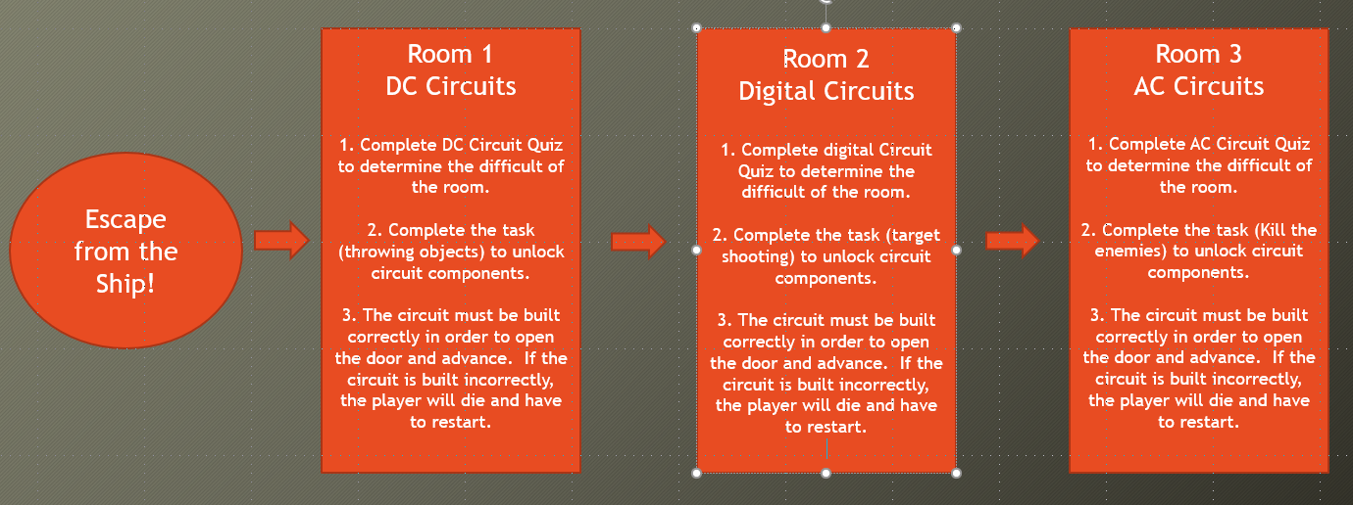

1. Implementation Plan

## Tasks

* Task 1. Development Engine Configuration
  + Subtask 1. Unity vs. Unreal Engine
  + Unreal Engine
    - More powerful engine – Allows for more stunning visuals
    - Only recently became free to use, less documentation available
    - Utilizes C++ for programming
  + Unity
    - Possesses a learning curve, but much more user friendly for beginners
    - Vast amount of documentation available publicly online
    - Utilizes C## for programming
  + Subtask 2. Chose Unity – Get familiarized with the engine
  + Go through step by step tutorials
  + Study the premade games and how they are put together
  + Experiment with different features
  + Internet and textbook guides on using the software
  + Subtask 3. Lay out a plan for the game
  + Used the preparation time to brainstorm and figure out what can be achieved using the unity engine
  + Define objectives
    - Quiz on general electrical engineering knowledge
    - Test circuit design skills
    - Implement fun tasks, not necessarily focused on electrical engineering, but necessary to progress through the game.
  + Define the setting in which the game takes place
    - Chose a futuristic, outer space, alien space ship theme
    - Acquired assets from the Unity Asset Store in order to establish this
* Task 2. Development
  + Subtask 1. Room 1 – DC Circuits
  + Design on the environment/room

## Timeline/Milestones/Delivery Plan

1. Project Timeline and Delivery Plan

|  |  |  |
| --- | --- | --- |
| Time | Task | Comments |
| Semester 1  Week 9 | Task 1 | Dedicated time to get a solid understanding of Unity and Virtual Reality. Subtasks 2 and 3 took up most of this time. This preparation time was vital as it allowed for a much easier experience leading into following development tasks. |
| Week 10 - Present | Task 2 | Developing the first room of the game. This includes both the building of the environment, along with the coding. |

1. Implementation

For each task/subtask, create a section and add tech details of how it is implemented.

## Implementation of Task 1.

## Implementation of Task 1.

…

1. Conclusion.

By the end of the project, conclude the project and your learning experience.

Acknowledgement

If you get help or support from someone else (besides the team member and the advisor) and want to show your appreciation, put here (**do not include the advisor**).

Appendix

You can put reference info here, including: i) specs of components used in the system, ii) source code (must be here but not in the body text), iii) CAD figures, etc.

1. Component Specs
2. Specs of Arduino Due

...

1. Specs of Raspberry Pi

…

1. Source Code.
2. Source Code of Graphic User Interface

…

1. Source Code of Robotic Arm

…

REFERENCES

[1] Teed, R. (2018, May 07). Game-Based Learning. Retrieved December 12, 2018, from https://serc.carleton.edu/introgeo/games/index.htm